PROJECT 1 - THIN WALL

Jose Rodriguez
Department of Mechanical Engineering, The University of Texas at Dallas, TX, USA
February 27th 2025
Problem Statement

Additive manufacturing is a method of modern engineering allowing the possibility to extrude material on the spot without requiring a large manufacturing site. Incredibly, advancements in three-dimensional technology has allowed for consumer wide scale for individual projects. In this particular example, the project’s objective is to simulate a more industrial version of three-dimensional extrusion using a high-powered beam on a metal substrate and the physics behind the applications parameters. The simulation will include convection, a heat transfer process that occurs due to the movement of fluids like air or water. It is driven by temperature differences across the fluid and is the dominant form of heat transfer in liquids and gases. Moving heat flux is seeing how heat moves along the direction of the beam and the temperature throughout the substrate.

Introduction

AM: What is it? Why is it needed? How is it done? Where is it used?

Additive manufacturing is the process of successive layering through deposition of material. This procedure is a low-cost, effective way of manufacturing substrates through the use of three-dimensional modelling software. As the CAD model is produced, the machine reads the file then adds the successive later of liquid powder sheer or other fabrication to create the piece. [3] ASTM defines seven categories of material deposition under the same additive manufacturing:
- Directed Energy Deposition
- Hybrid Manufacturing
- Powder Bed Fusion
- Sheet Lamination
- Material Extrusion
- Binder Jetting
- Material Jetting
Additive manufacturing is a fairly new way of manufacturing that quickly executes design to fabrication from a few days to just a few hours. This can range from many different materials from polymers, to living cells and dense substrates such as stainless steel through complex shaping that traditional practices cannot fabricate. In this study, transient thermal analysis is performed on thin wall structures to understand heat accumulation, the effect of a moving heat source, and temperature distribution across the substrate and the built structure. Objectives of this simulation is to analyse the effect of a moving heat source on temperature distribution during the deposition process and to observe thermal gradients and its impact on material properties. The paper will end with a discussion on the important considerations for standardization of mechanical characterization/simulation of AM on the thin wall substrate.
2.1 AM Properties
- Thermal Conductivity: Governs the rate of heat transfer within the material.
- Density: Affects the thermal response and heat diffusion during welding.
- Heat Input: Defined by the heat flux or moving heat source used in the simulation.
- Thermal Convection: Models heat dissipation into the surrounding environment.
- Heat Flux: also known as “Thermal Flux” is a flow of energy per unit of time $\frac{W}{m^{2}}$
- Convection: transfer of heat or energy of one conductive end to another

Methodology
3.1 description
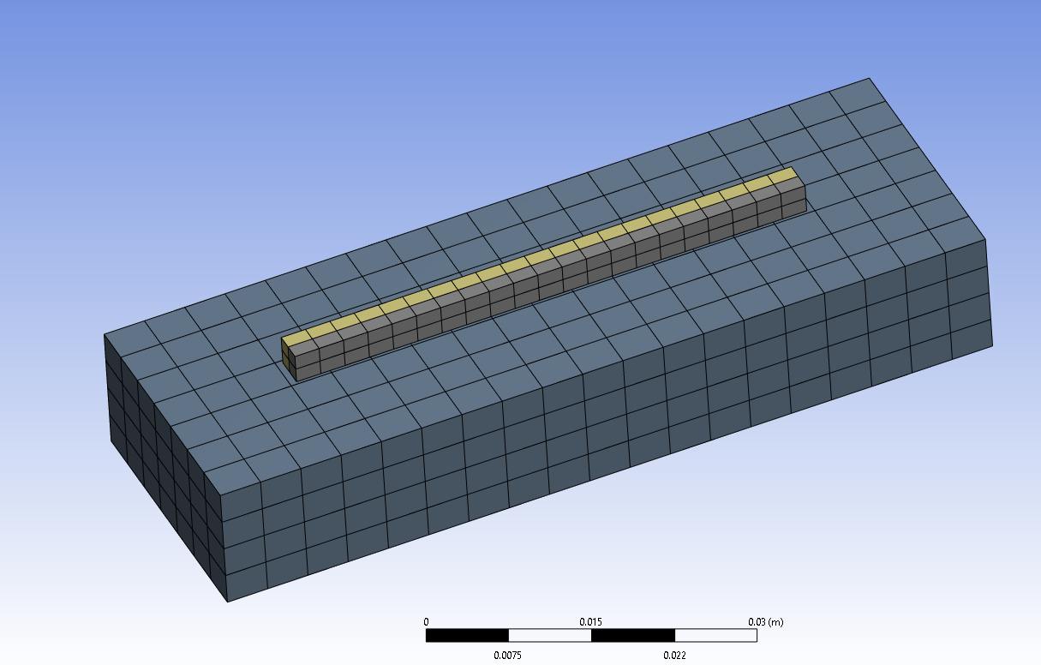
Figure 1: Mesh model of thin wall
The Thin Wall substrate’s geometry is constructed using Solidworks CAD software. This geometry is modelled and constructed to match the size of a real life example of a substrate as with variations in thickness and height to assess thermal effects. The structure is considered flexible in thermal analysis to capture deformation effects due to temperature variations at melting point for stainless steel. Furthermore, the thin wall extruded on top of the base is meant to illustrate the deposition of material in a straight line path, and continues to repeat the process layer by layer until the process is complete and the geometry constructed.

3.2 Model Setup
The SolidWorks CAD setup involved creating a parametric 3D representation of the thin wall structure and its substrate. The model was designed to reflect the dimensions and geometric constraints essential for the additive manufacturing process. The CAD model consists of a rectangular base substrate with a thin wall feature extending along its length, as depicted in the provided images in Figure 2 and 3. Key dimensions include a base height of 0.50 inches, a thin wall thickness of 0.12 inches, and a total height of 3.00 inches with a ±0.01 tolerance. These specifications ensure accurate simulation of heat transfer and deposition effects during the transient thermal analysis.
Dimensions
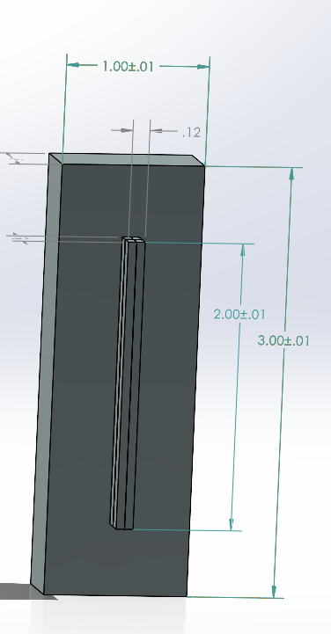
Figure 2

Dimensions
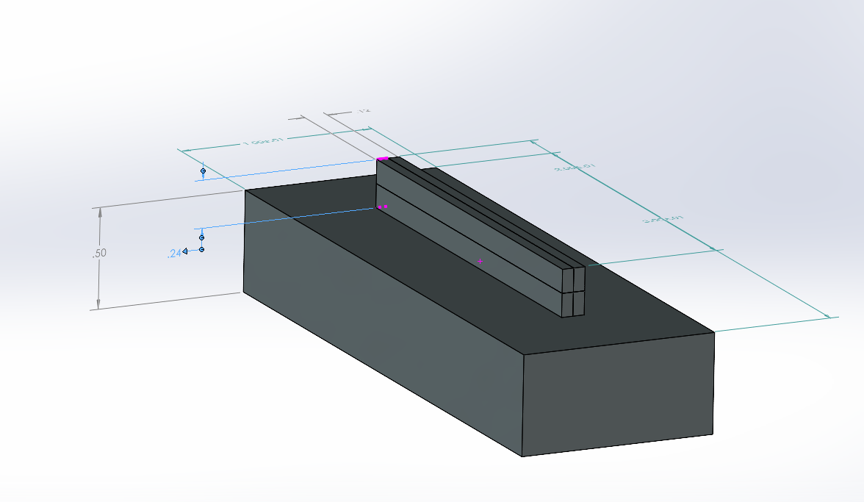
Figure 3

3.3 Simulation setup
The transient thermal analysis was conducted using FEM-based ANSYS to capture the heat transfer dynamics during the additive manufacturing process. The simulation setup included the following key steps: The CAD model of the thin wall and substrate was imported and refined for analysis later following an adaptive mesh refinement strategy was applied, ensuring finer elements in the heat-affected zone to capture temperature gradients accurately. Assigning the material as 316 stainless steel for all bodies of the geometry. The simulation was constructed by constructing rigid bonds for each contact: the thin walls were split in two setting up bonds between them and bonds below in contact with the base. Moving heat flux, as viewed in Table 1, was set at a velocity of 0.005 m/s for 5 seconds not to exceed the geometry length and a melting temperature of 1350°C.
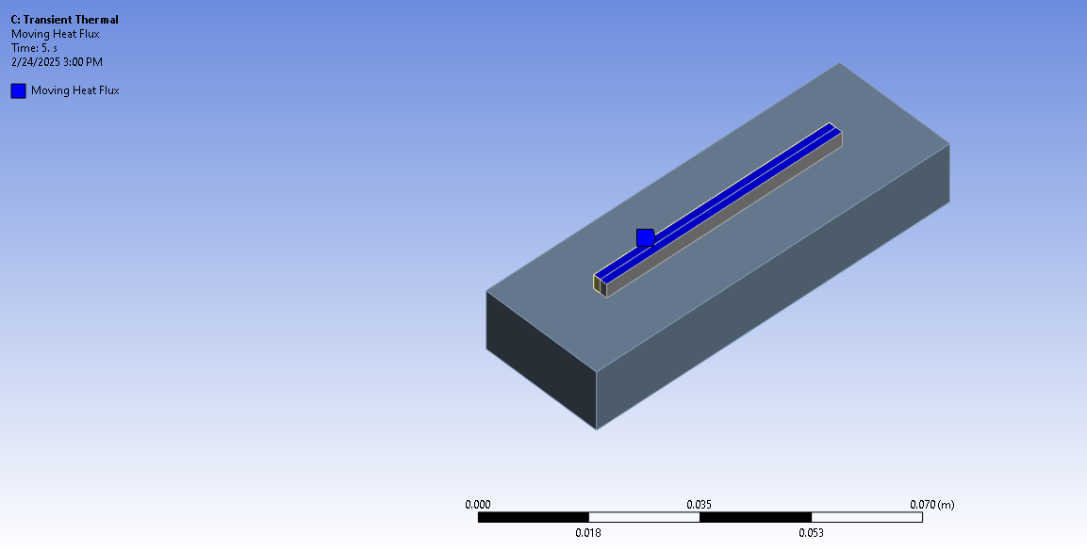
Figure 4: Moving heat flux faces
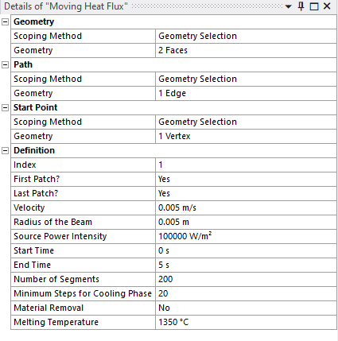
Table 1: Details of Moving Heat Flux ( $\frac{W}{m^{2}}$ )

Loads and boundary conditions:
No loads have been applied nor analysed for this study as the main focus is to view the conductivity and convection of the heat in and surrounding the material. The self-weight of the structure was considered using gravity loading but irrelevant to the study. Table 2 shares details of 316 stainless steel. Stainless steel was set to near melting point (1350°C) in order for the deposition to layer. [8]
Materials and their properties
Properties | Stainless Steel
Density | 7.93 $\frac{g}{cm^{3}}$
Youngs Modulus | 193 GPa
Poisson ration | 0.30-0.31
Yield Strength | 502 MPa
Ultimate strength | 860 MPa
Melting Point | 1375-1400°C  (2507-2552°F)
Table 2: material and properties of 316 stainless steel [3]
The thermal and structural response of the thin wall structure was analyzed under boundary constraints to accurately simulate the additive manufacturing process. Moving heat flux was applied along the path of deposition to represent the energy input from the heat source, with the initial temperature set to ambient conditions 22°C supported by Figure 4. The heat load was distributed over the deposition area, allowing a gradual build-up of temperature as each successive layers were deposited. Convection was applied to account for realistic heat dissipation surrounding the substrate simulating the exposed surfaces and simulating natural cooling effects On the structural side, the substrate base was fully constrained, preventing any displacement and simulating a rigid fixture during the process. This restriction eliminated all DoF (Degrees of Freedom) at the bottom surface while allowing the deposited layers to expand freely under thermal effects. These constraints helped simulate the thermal effects of heat, the path of the moving heat flux and where deformity may occur.
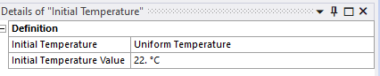
Figure 5: Initial Temperature information

Meshing:
Each component is decretized into finite elements. The minimum element size for finite element analysis depends on the geometry. Based on the results chosen are recorded on table 3 below:
 | Thin Wall
Minimum element size | 0.5 mm to 1.0 mm in the heat affected zone
Resolution | 4
Number of elements | 616
Number of nodes | 3724
Shape | Hexahedral/ Tetrahedral
Table 3: Number of elements and nodes

Contacts:
3 contact regions were applied: The interface between the deposited layers and the substrate was modeled as bonded to simulate adhesion, ensuring load transfer between layers without separation and both bottom faces of each modelled bar to the face of the substrate’s base.

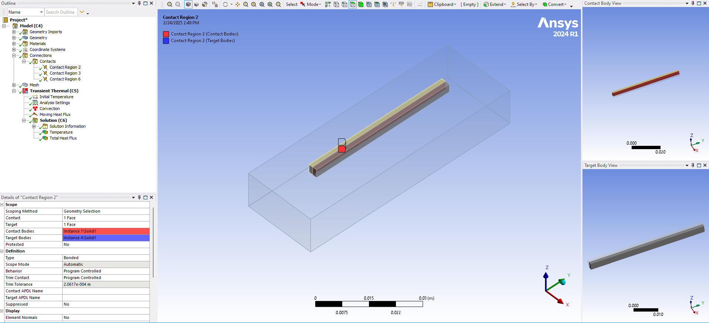
Figure 6: Bonded contact example of thin wall substrate

Analysis settings
Before running the simulation and calculations, the analysis settings were configured to ensure accurate transient thermal analysis. The simulation was set up with a single-step analysis to capture the thermal evolution over time. Under analysis setting, number of steps were set to 1 to fill a result every 1 step time for 5 seconds. Minimum step time was set to 0.005 s to allow gradual heat progression as viewed in the chart below. This preventing excessive computational load while maintaining accuracy. Settings were also set to “Program Controlled” to auto solve thermal effect as the heat moved through the thin wall over a set period of time.
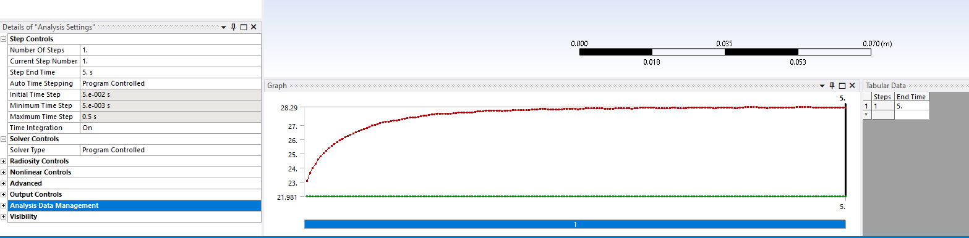
Table 4: Analysis setting

Solution:
The solution for the finite elements model was solved using ansys 24 version.

Results

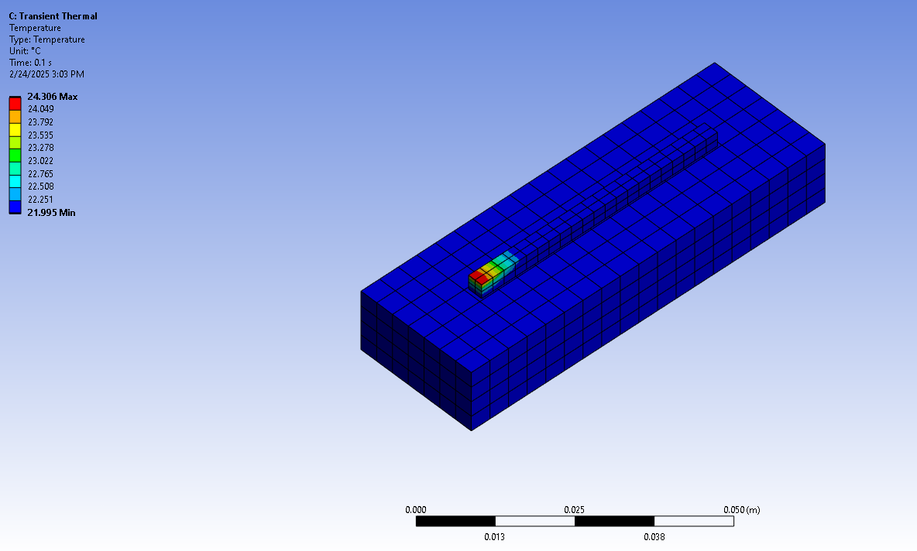 | Temperature
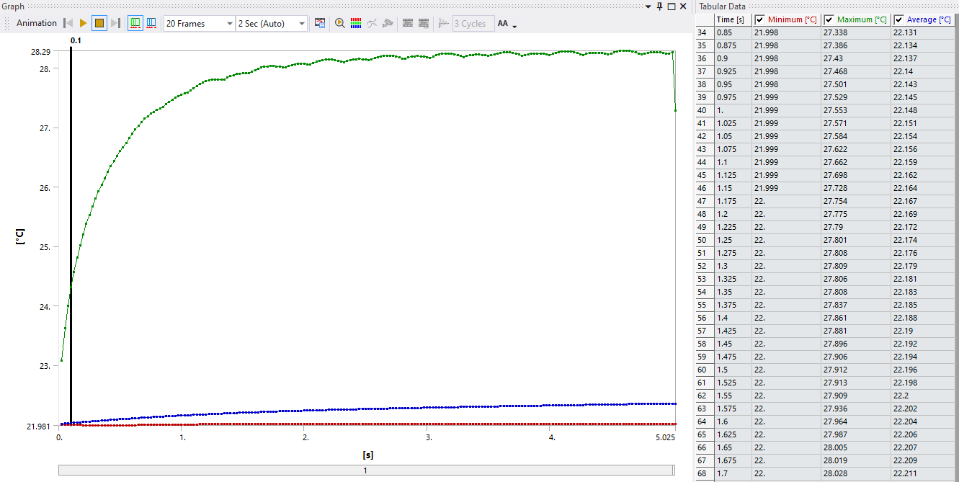 | Temperature graph
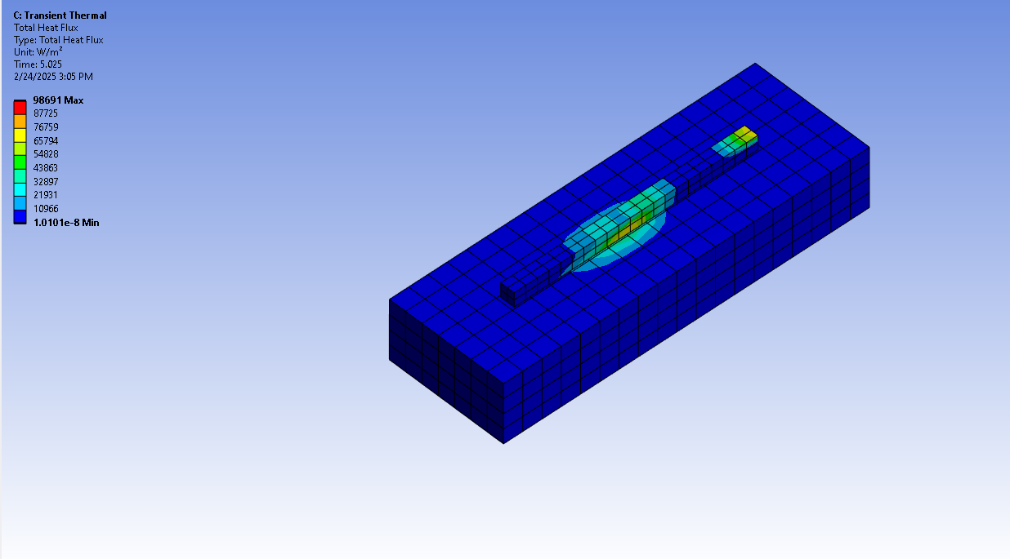 | Heat Flux  Maximum achieved energy:  98,691$\frac{W}{m^{2}}$
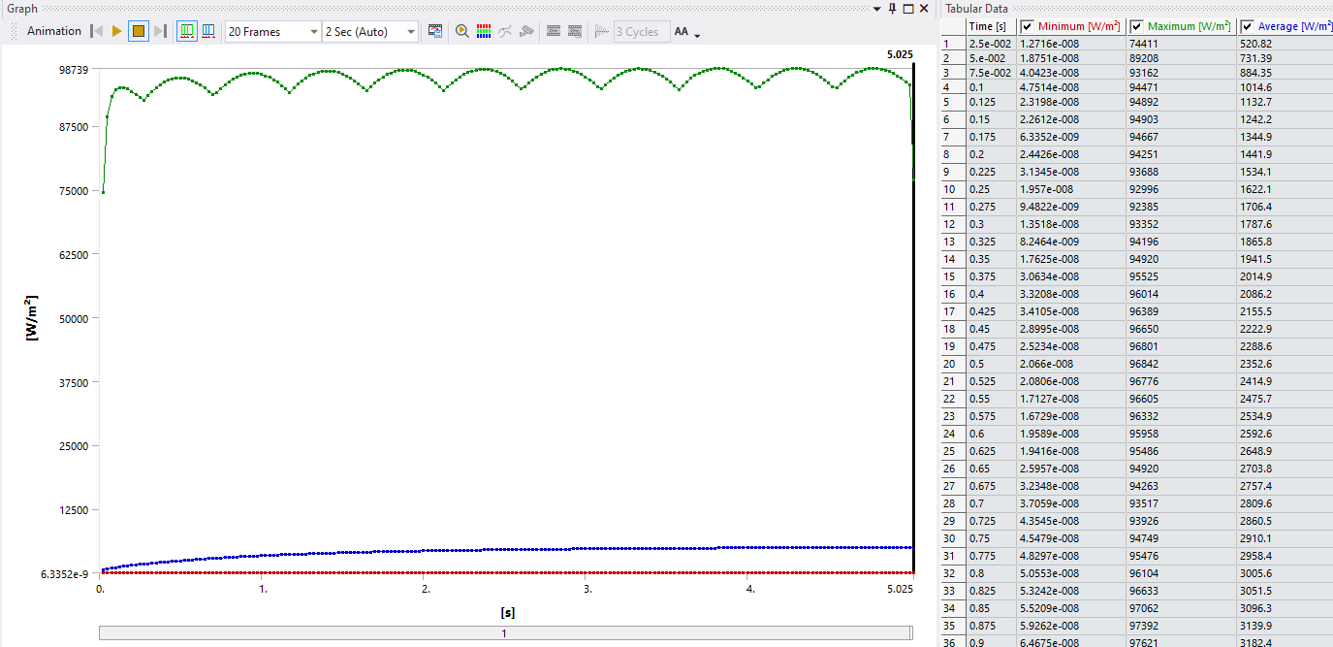 | Heat Flux graph

Conclusion

In conclusion, Metal Additive Manufacturing revolutionized the production of complex geometries and shapes that traditional manufacturing techniques cannot do thanks to the advanced technology of three-dimensional printing. In this study, the thin wall simulation directing energy deposition path along the set path illustrated the thermal effects, heat accumulation, and temperature distribution throughout the geometry of the substrate using material 316 stainless steel. The simulation provided valuable insight into providing temperature changes within and around the deposition area of the thin wall, reaching a heat flux of near 99,000 $\frac{W}{m^{2}}$. Future work could involve experimental validation of the simulation results, refinement of process parameters for better thermal management, or expanding this simulation to real world experimentation such as Wire-Arc Additive manufacturing. The insights gained from this study contribute to advancing AM technology, paving the way for its broader application in aerospace, automotive, and in-space manufacturing.

References
[1]ASM material data sheet. (n.d.). https://asm.matweb.com/search/SpecificMaterial.asp?bassnum=MTP641

[2] “Basics to Finite Element Analysis in any CAE Software” by Kishore MN
[3] Additive Manufacturing. Additive Manufacturing - an overview | ScienceDirect Topics. (n.d.). https://www.sciencedirect.com/topics/engineering/additive-manufacturing
[4] Author links open overlay panelJohn Ryan C. Dizon a b, a, b, c, Highlights•A compilation of ASTM and ISO mechanical test standards frequently used for testing of 3D-printed parts.•An exhaustive summary of mechanical properties of 3D-printed components.•A comprehensive discussion of the various post-processing techniqu, printing, A., Chapiro, M., Leon, A. D., Wang, X., Gao, W., Berman, B., Stansbury, J., Melchels, F., Kalita, S., Lee, J., Mohammed, J., Liu, R., Goh, G., Singh, S., … Kira. (2017, December 9). Mechanical characterization of 3D-printed polymers. Additive Manufacturing. https://www.sciencedirect.com/science/article/pii/S2214860417302749
[5] World Material. (n.d.). 304 stainless steel properties: SS304 composition, density, yield strength, thermal conductivity, hardness, modulus of elasticity. https://www.theworldmaterial.com/304-stainless-steel/
[6] Unionfab. (2024, March 23). Yield strength of steel: A comprehensive guide. https://www.unionfab.com/blog/2024/03/yield-strength-of-steel
[7] Engineeringtoolbox, E. (2024, August 20). Young’s modulus, tensile strength and yield strength values for some materials. Engineering ToolBox. https://www.engineeringtoolbox.com/young-modulus-d_417.html
[8] Steel, Marlin. “What Is the Melting Point of Stainless Steel?” Custom Wire Products and Metal Fabrication, www.marlinwire.com/blog/what-is-the-melting-point-of-stainless-steel. Accessed 27 Feb. 2025.

